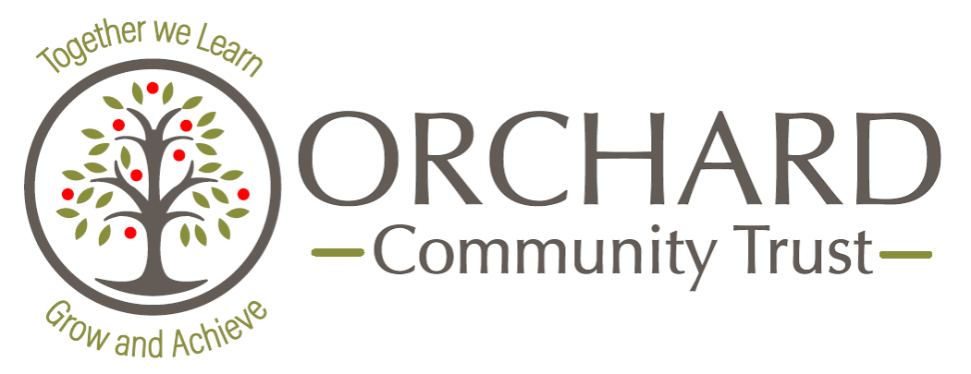

**Quality First Teaching**

**OUR VISION**

Our vision and mission is to have fully inclusive schools working in our Trust, that fully embrace all stakeholders and which celebrate individuality and success by offering a high-quality education and range of opportunities, where everyone makes excellent progress.

**Orchard Community Trust

|  |  |
| --- | --- |
| **Before**: | * Implement curriculum maps / Long term plans * Ensure an effective sequence of lessons * Use AfL from previous lesson to inform * Use prior learning * Subject knowledge * Select appropriate resources and pedagogical strategies to suit the needs of the class * Share lesson with any additional adults, in particular their role * Pre-empt misconceptions |

|  |  |  |  |  |
| --- | --- | --- | --- | --- |
| **During**: | * High expectations of behaviour and attitude. * Positive learning environment and consistent routines. * Targeted AfL questioning and addressing misconceptions. * Use of cognitive and metacognitive strategies. * Effective use of adults and resources, so that the needs of all learners are met. * Effective use of lesson time. | | | |
| **BEGINNING EXPOSITION APPLICATION END** | | | |
| * Link to prior lesson and / or learning retrieval practice * Share / teach vocabulary * Share LO and intended outcome | * Pitch of lessons provides appropriate challenge for all * Small-steps modelling * Clear explanations * ‘Talk Less Teaching’ strategies * Collaborative learning * Opportunities to practise * Share and model good examples | * Effective scaffold and challenge * Flexible groupings * Implementation of adaptive teaching strategies * Monitoring of whole class learning, including AfL strategies * Supporting and re-directing learning Share successes | * Review of intended learning outcome Share successes |

|  |  |
| --- | --- |
| **After**: | * Assessment and next steps * Take feedback from any additional adults * Plan / adapt planning for next lesson |

**Quality First Teaching** is a whole-class teaching concept that focuses on inclusive and high-quality teaching for every pupil in the classroom. Schools within our Trust retain their autonomy, however all our schools follow the principles outlined below to ensure that all of our pupils have the same entitlement across the Trust.