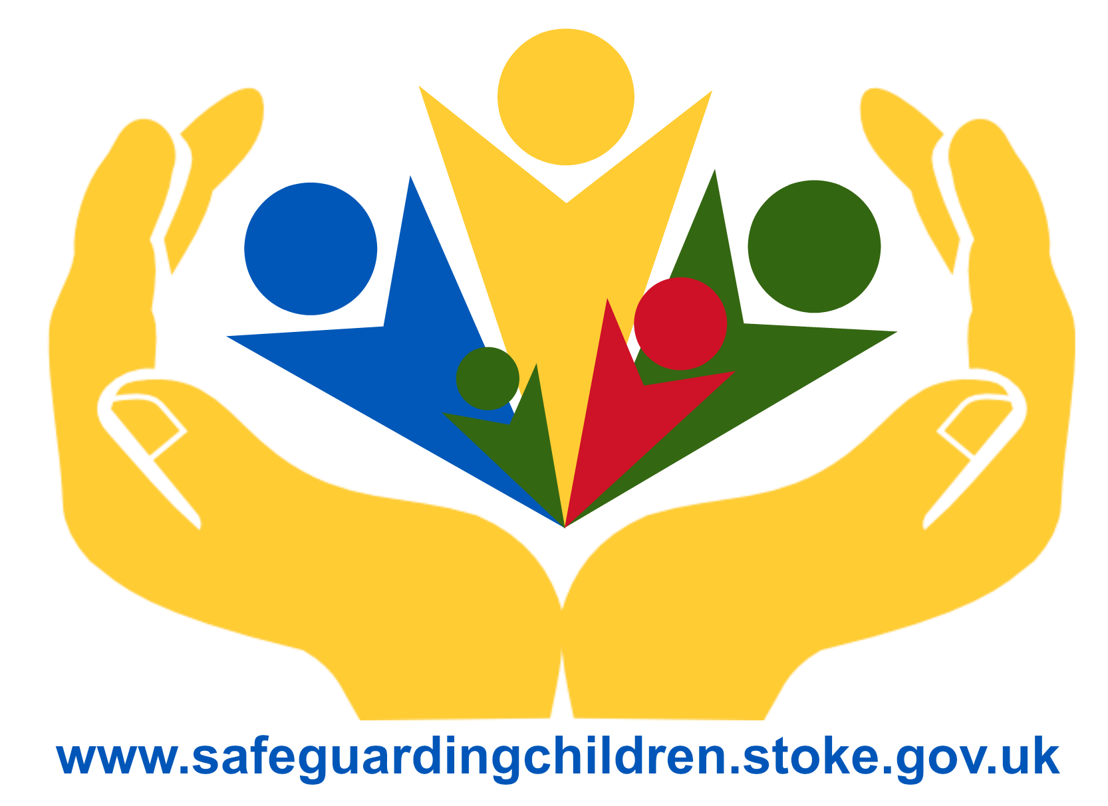

Safeguarding Policy:-

Preventing Extremism and Radicalisation
in Education Settings



Contents

- Introduction 3

- Definitions 3

- Guidance and Legislation 3-4

- School Ethos and Practice 4-5

- Teaching Approaches 5-6

- Use of External Agencies and Speakers 6-7

- Whistle Blowing 7

- Child Protection 7

- Role of the Designated Safeguarding Lead (DSL) 7-8

- Training 8

- Recruitment 8-9

- Role of Governing Body 9

- Stoke-on-Trent PREVENT Programme 9-10

- Channel Panel 10

- Reporting Online Material 11

- Department for Education 11

Stoke-on-Trent and Staffordshire Safeguarding Children Board express their sincere thanks to the HEADTEACHERS’ PREVENT BOARD who made an enormous contribution to the development of this document.

- Introduction

Etruscan Primary School is committed to providing a secure environment for pupils, where they feel safe and are kept safe. All adults at Etruscan Primary School recognise that safeguarding is everyone’s responsibility, irrespective of the role they undertake and whether or not their role has direct contact or responsibility for children and young people.

Children are vulnerable to extremist ideology and radicalisation. Similar to protecting children from other forms of harms and abuse, protecting children from this risk is part of Etruscan Primary School’s safeguarding approach.

- Definitions

Ideology - a set of beliefs.

Extremism - a vocal or active opposition to fundamental British values, including democracy, the rule of law, individual liberty and the mutual respect and tolerance of different faiths and beliefs. This also includes calling for the death of members of the armed forces.

Radicalisation - the process by which a person comes to support terrorism and extremist ideologies associated with terrorist groups.

Terrorism - an action that endangers or causes serious violence, damage or disruption and is intended to influence the Government or to intimidate the public and is made with the intention of advancing a political, religious or ideological cause.

- Guidance and Legislation

The Preventing Extremism and Radicalisation Safeguarding Policy draws upon the guidance contained in:-

- Stoke-on-Trent and Staffordshire Safeguarding Children Board procedures
- Keeping Children Safe in Education; DfE: September 2020
- Teaching Approaches that help Build Resilience to Extremism among Young
People; DfE 2011
- Report into Allegations Concerning Birmingham Schools Arising from Trojan Horse Letter; Peter Clarke; July 2014.
- Promoting Fundamental British Values as part of SMSC in Schools; Nov 2014
- OFSTED School Inspection Handbook; November 2019
- Prevent duty guidance, updated April 2019

In adhering to this policy and the procedures therein, staff and visitors will comply with our statutory duties to:-

- Safeguard and promote the welfare of all children as set out in s175 and s157of the Education Act 2002.

- Contribute to the delivery of the outcomes for all children, as set out in s10 (2) of the Children Act 2004.

- Have due regard to the need to prevent people from being drawn into terrorism, as set out in s26 of the Counter-Terrorism and Security Act 2015.

- School Ethos and Practice

Etruscan Primary School recognises the Governments concern that the UK continues to face a threat from terrorism. One security concern is the potential for British citizens and residents to become radicalised and commit acts of violence or terrorism.

Violent Extremism is defined by the Crown Prosecution Service (CPS) as:

"The demonstration of unacceptable behaviour by using any means or medium to express views, which:

- Encourage, justify or glorify terrorist violence in furtherance of particular beliefs;
- Seek to provoke others to terrorist acts;
- Encourage other serious criminal activity or seek to provoke others to serious criminal acts;
- Foster hatred which might lead to inter-community violence in the UK."

Extremism can take many forms including that linked to Far Right / Neo Nazi / White Supremacist, Al Qaeda/Daesh ideologies, Irish Nationalist and Loyalist paramilitary groups, and that linked to Animal or Environmental Rights movements. It also includes school massacre ideology and Incel Movement.

Our school is a safe place where pupils can explore controversial issues safely and where our teachers encourage and facilitate this – we have a duty to ensure this happens. However there is no place for extremist views of any kind in our school, whether from internal sources - pupils, staff or governors; or external sources - school community, external agencies or individuals.

As a school we recognise that extremism and exposure to extremist materials and influences can lead to poor outcomes for children and so should be addressed as a safeguarding concern as set out in this policy. We also recognise that if we fail to challenge extremist views we are failing to protect our pupils.

Extremists of all persuasions aim to develop destructive relationships between different communities by promoting division, fear and mistrust of others based on ignorance or prejudice and thereby limiting the life chances of young people. Education is a powerful weapon against this; equipping young people with the knowledge, skills and critical thinking, to challenge and debate in an informed way.

Therefore, we will provide a broad and balanced curriculum, delivered by skilled professionals, so that our pupils are enriched, understand and accept difference and diversity and also to ensure that they thrive, feel valued and not marginalised.

Furthermore we are aware that young people can be exposed to extremist influences or prejudiced views from an early age, which emanate from a variety of sources, including the internet, and at times pupils may themselves reflect or display views that may be discriminatory, prejudiced or extremist, including using derogatory language.

Any prejudice, discrimination or extremist views, including derogatory language, displayed by pupils or staff will always be challenged and where appropriate dealt with in line with our Behaviour Policy for pupils and the Code of Conduct for staff.
Where misconduct by a teacher is proven, the matter will be referred to the National College for Teaching and Leadership for their consideration as to whether a Prohibition Order is warranted.

As part of wider safeguarding responsibilities school staff will be alert to:-

- Disclosures by pupils of their exposure to the extremist actions, views or materials of others outside of school, such as in their homes or community groups, especially where pupils have not actively sought these out.

- Graffiti symbols, writing or art work promoting extremist messages or images.

- Pupils accessing extremist material online, including through social networking sites.

- Parental reports of changes in behaviour, friendship or actions and requests for assistance.

- Partner schools, local authority services, and police reports of issues affecting pupils in other schools or settings.

- Pupils voicing opinions drawn from extremist ideologies and narratives.

- Use of extremist or ‘hate’ terms to exclude others or incite violence.

- Intolerance of difference, whether secular or religious or, in line with our equalities policy, views based on, but not exclusive to, gender, disability, sexuality, ethnicity or culture.

- Attempts to impose extremist views or practices on others.

Our school will closely follow any locally agreed procedure as set out by the Local Authority and the Local Safeguarding Children Board’s agreed processes and criteria for safeguarding individuals vulnerable to extremism and radicalisation.

- Teaching Approaches

We will all strive to eradicate the myths and assumptions that can lead to some young people becoming alienated and disempowered, especially where the narrow approaches children may experience elsewhere may make it harder for them to challenge or question these radical influences. In our school, this will be achieved by good teaching, primarily via PSHE; but also by adopting the methods outlined in the Government’s guidance ‘Teaching approaches that help build resilience to extremism among young people’ DfE 2011.

We will ensure that all of our teaching approaches help our pupils build resilience to extremism and give pupils a positive sense of identity through the development of critical thinking skills.

We will ensure that all of our staff are equipped to recognise extremism and are skilled and confident enough to challenge it.

We will be flexible enough to adapt our teaching approaches as appropriate, so as to address specific issues to become even more relevant to the current issues of extremism and radicalisation. In doing so we will apply the ‘key ingredients’ for success following the three broad categories of:-

- Making a connection with young people through good [teaching] design and a pupil centred approach.
- Facilitating a ‘safe space’ for dialogue, and
- Equipping our pupils with the appropriate skills, knowledge, understanding and awareness for resilience.

Therefore this approach will be embedded within the ethos of our school so that pupils know and understand what safe and acceptable behaviour is in the context of extremism and radicalisation.

This will work in conjunction with our schools approach to the spiritual, moral, social and cultural development of pupils as defined in OFSTED’s School Inspection Handbook and will include the sound use of assemblies to help further promote this rounded development of our pupils.

Our goal is to build mutual respect and understanding and to promote the use of dialogue not violence as a form of conflict resolution. We will achieve this by providing a curriculum that includes:-

- Citizenship programmes
- Open discussion and debate
- Work on anti-violence and a restorative approach addressed throughout curriculum
- Focussed educational programmes

We will also work with local partners, families and communities in our efforts to ensure our school understands and embraces our local context and values in challenging extremist views, and to assist in the broadening of our pupil’s experiences and horizons.

We will promote the values of democracy, the rule of law, individual liberty, and mutual respect and tolerance for those with different faiths and beliefs. We will teach and encourage pupils to respect one another and to respect difference, especially those of different faith or no faith. It is indeed our most fundamental responsibility to keep our pupils safe and prepare them for life in modern multi-cultural Britain and globally.

We will help support pupils who may be vulnerable to such influences as part of our wider safeguarding responsibilities and where we believe a pupil is being directly affected by extremist materials or influences, we will ensure that that pupil is offered support through referral to the Stoke-on-Trent Prevent Programme – see section 13.

- Use of External Agencies and Speakers

We encourage the use of external agencies or speakers to enrich the experiences of our pupils. However, we will positively vet those external agencies, individuals or speakers who we engage to provide such learning opportunities or experiences for our pupils.

Such vetting is to ensure that we do not unwittingly use agencies that contradict each other with their messages or that are inconsistent with, or are in opposition to, the school’s values and ethos. We must be aware that in some instances, the work of external agencies may not directly be connected with the rest of the school curriculum so we need to ensure that this work is of benefit to pupils.

Our school will assess the suitability and effectiveness of input from external agencies or individuals to ensure that:-

- Any messages communicated to pupils are consistent with the ethos of the school and do not marginalise any communities, groups or individuals.

- Any messages do not seek to glorify criminal activity or violent extremism or seek to radicalise pupils through extreme or narrow views of faith, religion or culture or other ideologies.

- Activities are properly embedded in the curriculum and clearly mapped to schemes of work to avoid contradictory messages or duplication.

- Activities are matched to the needs of pupils.

- Activities are carefully evaluated by the school to ensure that they are effective.

We recognise, however, that the ethos of our school is to encourage pupils to understand opposing views and ideologies, appropriate to their age, understanding and abilities, and to be able to actively engage with them in informed debate, and we may use external agencies or speakers to facilitate and support this.

Therefore by delivering a broad and balanced curriculum, we will strive to ensure our pupils recognise risk and build resilience to manage any such risk themselves, where appropriate to their age and ability; but also to help pupils develop the critical thinking skills needed to engage in informed debate

- Whistle Blowing

Where there are concerns of extremism or radicalisation, pupils and staff are able to discuss this with the Designated Safeguarding Lead. If, for any reason they feel unable to do this, then they are able to make use of our internal systems to Whistle Blow or raise any issue in confidence. Please refer to School Whistle Blowing Policy.

- Child Protection

Please refer to our Safeguarding and Child Protection Policy for the full procedural framework.

Staff will be alert to the fact that whilst Extremism and Radicalisation is broadly a safeguarding issue there may be some instances where a child or children may be at direct risk of harm or neglect.

For example; this could be due to a child displaying risky behaviours in terms of the activities they are involved in or the groups they are associated with; or staff may be aware of information about a child’s family that may equally place a child at risk of harm. (These examples are for illustration and are not definitive or exhaustive.) Therefore all adults working at the school (including visiting staff, volunteers’ contractors, and students on placement) are required to report instances where they believe a child may be at risk of harm or neglect to the Designated Safeguarding Lead.

- Role of the Designated Safeguarding Lead (DSL)

The DSL is: Chris Crook, Headteacher
The Deputy DSL are: Laura Tranter, Deputy Headteacher, Mandy Cox, Home School Link Worker, Karla Thorley, Assistant Headteacher

The role of the DSL is set out in our Safeguarding and Child Protection Policy.

The DSL is the focus person who school staff, and others, may come to if they have concerns about an individual child’s safety or well-being, and they are the first point of contact for external agencies.

The DSL is also the person who leads on concerns regarding extremism or radicalisation. Where there are concerns regarding extremism and radicalisation, the DSL will liaise with the Stoke-on-Trent Prevent Education Officer and make referrals where appropriate – see section 13.

There is no single way of identifying whether a child is likely to be susceptible to an extremist ideology. Background factors combined with specific influences such as family and friends may contribute to a child’s vulnerability. Similarly, radicalisation can occur through many different methods (such as social media) and settings (such as the internet).

However, it is possible to protect vulnerable people from extremist ideology and intervene to prevent those at risk of radicalisation being radicalised. As with other safeguarding risks, staff should be alert to changes in children’s behaviour, which could indicate that they may be in need of help or protection. Staff should use their judgement in identifying children who might be at risk of radicalisation and act proportionately which may include the Designated Safeguarding Lead (or Deputy) making a referral to Prevent.

- Training

Whole school training on Safeguarding and Child Protection will be organised for staff and governors at least every three years. This training should be approved by the Local Safeguarding Children Board and will, in part, include training on extremism and radicalisation and its safeguarding implications.

The DSLs will attend training courses as necessary and the appropriate inter-agency training organised by the Local Safeguarding Children Board at least every two years.

All school staff will undertake Home Office approved WRAP Training (Workshop to Raise Awareness of Prevent;) also sometimes referred to as ‘Prevent training.’

Whole school WRAP/Prevent training (Home Office approved;) is delivered by Sarah Dyer, Prevent Education Officer (Sarah.Dyer@stoke.gov.uk)

For information regarding multi agency training on Challenging Extremism see SCB website -http://www.safeguardingchildren.stoke.gov.uk/ccm/navigation/professionals/training/

- Recruitment

The arrangements for recruiting all staff, (permanent, temporary and volunteers;) to our school will follow statutory guidance in Keeping Children Safe in Education 2020.

We will apply safer recruitment best practice principles and sound employment practice in general, which include, but are not limited to, ensuring that DBS checks are made at the appropriate level, that references are always received and checked and that we complete and maintain a single central record of such vetting checks.

We will be alert to the possibility that persons may seek to gain positions within our school so as to unduly influence our schools character and ethos. We are aware that such persons seek to limit the opportunities for our pupils thereby rendering them vulnerable to extremist views and radicalisation as a consequence.

Therefore, by operating safer recruitment best practice and by ensuring an ongoing culture of vigilance within our school, we will minimise the opportunities for extremist views to prevail.

- Role of Governing Body

The Governing Body of our School will undertake appropriate training to ensure that they are clear about their role and the parameters of their responsibilities as Governors, including their statutory safeguarding duties.

The Governing Body of our school will support the ethos and values of our school and will support the school in tackling extremism and radicalisation. www.gov.uk/government/publications/birmingham-schools-education-commissioners-report

In line with Recommendation 13 of Peter Clarke’s report details of our Governing Body will be published on our school website to promote transparency.

In line with the provisions set out in the DfE guidance ‘Keeping Children Safe in Education 2020’ the governing body will challenge the school’s senior management team on the delivery of this policy and monitor its effectiveness.

Governors will review this policy annually and may amend and adopt it outside of this timeframe in accordance with any new legislation or guidance or in response to any quality assurance recommendations pertaining to the delivery of this policy and the overall safeguarding arrangements made.

- Stoke-on-Trent PREVENT Programme
The Prevent Programme is Stoke-on-Trent’s response to the Government's national counter-terrorism strategy, which aims to stop people being drawn into or supporting terrorism. The national strategy focuses on three key areas which are:-

- respond to the ideological challenge of terrorism and the threat from those who promote it
- prevent people from being drawn into terrorism and ensure that they are given appropriate advice and support
- work with sectors and institutions where there are risks of radicalisation that we need to address

All schools and colleges are subject to a duty under section 26 of the Counter-Terrorism and Security Act 2015, in the exercise of their functions, to have “due regard to the need to prevent people from being drawn into terrorism”.

The Prevent duty is seen as part of Etruscan Primary School’s wider safeguarding obligations. Designated Safeguarding Leads and other senior leaders should familiarise themselves with the revised Prevent duty guidance: for England and Wales, especially paragraphs 57-76, which are specifically concerned with schools. The guidance is set out in terms of four general themes: risk assessment, working in partnership, staff training, and IT policies.

Stoke-on-Trent’s Prevent Programme is designed to:-

- divert vulnerable individuals away from the radicalisation process and ensure that they are given the appropriate advice and support through local safeguarding structures
- deter extremist groups from creating disharmony, division and spreading hate
- keep the majority safe from the few who seek to harm others
- ensure that sectors and institutions develop an appropriate response to tackle extremism
- ensure that media and wider public recognise that the illegal or extreme actions of a few individuals from a particular background do not reflect the values and views of others with the same background, faith or belief
- ensure that the reputation of the city and its residents is maintained and enhanced.

For further information about Stoke-On-Trent’s Prevent Programme please contact:
Shahzad Tahir, Community Cohesion Manager, Stoke-On-Trent City Council on 01782 238771 or Sarah Dyer, Prevent Education Officer, Stoke-on-Trent City Council on 01782 233239 / 07900135606.

- Channel Panel

Channel is a programme which focuses on providing support at an early stage to people who are identified as being vulnerable to being drawn into terrorism. It provides a mechanism for schools to make referrals if they are concerned that an individual might be vulnerable to radicalisation. An individual’s engagement with the programme is entirely voluntary at all stages. Guidance on Channel is available at: Channel Guidance, and a Channel Awareness e-learning programme is available for staff at: https://www.elearning.prevent.homeoffice.gov.uk/channel_awareness/01-welcome.html.

The Academy’s Designated Safeguarding Lead (and any deputies) should be aware of local procedures for making a referral to Prevent. As a Channel partner, the school or college will be asked to attend a Channel panel to discuss the individual referred to determine whether they are vulnerable to being drawn into terrorism and consider the appropriate support required.

It is important to trust your professional judgement – if you are concerned that someone is at risk of getting involved in extremism, you should discuss this with your DSL without delay.

The DSL will liaise with the Local Authority Prevent Education Officer and Staffordshire Police Prevent Team to discuss and make a referral if necessary.

When a referral is received, the Prevent team will, in partnership with other safeguarding professionals, investigate further to assess the nature and extent of the risk and develop the most appropriate support package for the individual concerned.

Staffordshire Police Prevent Team can be contacted on:-

Tel: 01785 232054 E-mail: prevent@staffordshire.pnn.police.uk

- Reporting online material promoting terrorism or extremism

The internet is used by some people to promote terrorism and extremism. Etruscan Primary School is committed to ensuring that students are not be able to access extremist ideas or materials online in school. We will challenge and report any terrorist and extremist content found online, which is offensive or illegal.

As private citizens, members of staff can also report such material, anonymously if necessary, by clicking on the button below:-

Examples include material such as:-
- articles, images, speeches or videos that promote terrorism or encourage violence
- content encouraging people to commit acts of terrorism
- websites made by terrorist or extremist organisations
- videos of terrorist attacks
The national Counter Terrorism Internet Referral Unit (CTIRU), which investigates the material, will try to secure the removal of the material as quickly as possible.

Department for Education – Preventing extremism in schools and children’s services
The DFE have set up a helpline that schools and other organisations working with children can contact if they have concerns about radicalisation:
Tel: 020 7340 7264 E-mail: counter.extremism@education.gov.uk
If you are concerned about extremism in a school or another organisation that works with children, or if you think a child might be at risk of extremism, contact their helpline.
Open Monday to Friday from 9am to 6pm (excluding bank holidays).
Educate Against Hate – Created by the DfE, the website offers parents, teachers and governors practical advice on protecting children from extremism and radicalisation.

Keeping children safe in education: Statutory guidance for schools and colleges (September 2020)
As defined in the Government’s Counter Extremism Strategy (2015)
As defined in the Revised Prevent Duty Guidance for England and Wales (10 April 2019)
As defined in the Terrorism Act 2000 (TACT 2000)

