
Etruscan Primary School
English Writing Teaching Units of Work EYFS – Year 6

“You should write because you love the shape of stories and sentences and the creation of different words on a page. Writing comes from reading, and reading is the finest teacher of how to write."
--Annie Proulx

Year 6
Term | Text | Genres
Autumn | 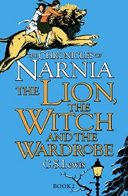  The Chronicles of Narnia – The Lion, the Witch and the Wardrobe – CS Lewis | - Poetry – changing seasons – Pie Corbett  - Non-chronological report  - Narrative embellishment – retell chapter 2  - Narrative embellishment – retell chapter 4  - Persuasive instructions
Spring | Street Child – Berlie Doherty  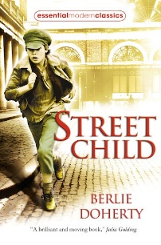 | - Poetry – workhouse poem  - Non-chronological report – workhouses  - Biography  - Narrative – character description – most villainous villain  - Narrative embellishment – retell – first person – dilemma when they escape
Summer | The Wolf Wilder – Katherine Rundell  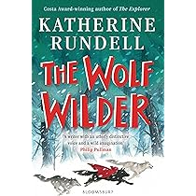 | - Fact file  - Non-chronological report  - Narrative embellishment – retell key events incorporating character’s thoughts and feelings
Year 5
Term | Text | Genres
Autumn | Who Let the Gods Out – Maz Evans  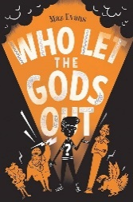 | • Poetry  • Fact file  • Non-chronological report – Greek Gods  • Narrative – retell key events with embellishment  • Formal letter  • Narrative embellishment – add in an additional character.  • Narrative innovation
Spring | Beowulf – Michael Morpurgo  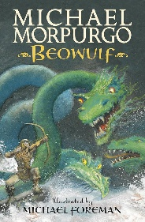 | - Poetry – Kennings – Evidence of Dragons – Pie Corbett  - Narrative – character analysis – Beowulf  - Narrative – retell Grendel’s attack on the Great Hall  - Narrative – retell key events with embellishment in the style of the author  - Diary  - Informal letter
Summer | Harry Potter and the Philosopher’s Stone – J.K. Rowling  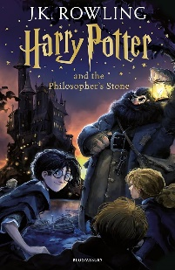 | - Poetry – The Magic Box by Kit Wright  - Biography  - Narrative innovation – create own wizard in the style of the author  - Narrative innovation – retell key events in chapter 2  - Formal letter  - Fact file  - Non-chronological report – a different creature  - Narrative innovation – character description – create a new character in the style of the author for chapter 10  - Narrative embellishment – retell key events of chapter 10 in the style of the author incorporating the new character.
Year 4
Term | Text | Genres
Autumn | Secrets of the Sun King – Emma Carroll  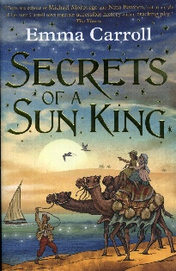 | - Instructions – mummification  - Biography – Howard Carter  - Non-chronological report – Ancient Egypt  - Short write – setting description – 1900s Egypt  - Narrative innovation – story of Selim and Ezra  - Recount – diary first person of the chariot race from Kyky’s perspective
Spring | Charlie and the Chocolate Factory – Roald Dahl  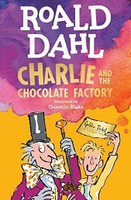 | - Poetry – write a poem in the style of the poet – Chocolate cake by Michael Rosen, A Matter of Taste by Eve Merriman  - Narrative embellishment – retell key events from chapter 1  - Persuasive instructions  - Persuasive advert – for a wonderful chocolate cake  - Narrative innovation – new chapter in the style of the author
Summer | How to Train Your Dragon – Cressida Cowell  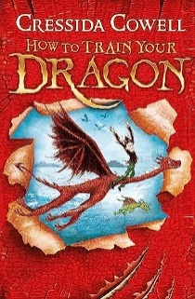 | - Non-chronological report – about a dragon  - Poetry – Kennings  - Fact file – about own dragon  - Short write – character description – create a dragon in the style of the author  - Short write – setting description – detailed description of dragon waking up in the style of the author  - Narrative embellishment – retell key events in the style of the author from chapter 2
Year 3
Term | Text | Genres
Autumn | Stone Age Boy – Satoshi Kitamura  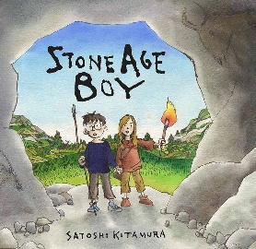 | - Poetry – Animal counting poem  - Fact file – Stone Age Animals  - Instructions – ‘How to was a…’  - Narrative retell  - Narrative embellishment – the setting  - Non-chronological report about Stone Age Animal  - Narrative – innovate a chapter – introduce a new character in the style of the author  - Recount of real event
Spring | Alice in wonderland  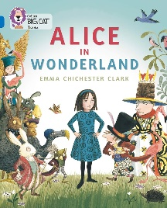 | - Poetry – Food  - Instructions- cakes for a Mad Hatters Tea Party  - Narrative retell – explode the moment e.g. Mad Hatter’s tea party or the moment on the lawn.  - Narrative innovation – add in another creature and interaction with them.  - Character – evil Queen – analyse different version – who is the most villainous queen?
 | Escape From Pompeii – Christina Balit  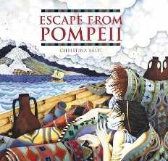 | - Non-chronological report  - Explanation text  - Narrative – innovation  - Narrative embellishment
Summer | Fantastic Mr Fox  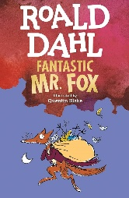 | - Non chronological report – animals that burrow/dig e.g. fox, badger  - Poetry – animal counting poem (built on from Stone Age Boy)  - Narrative innovation – create a farmer character in the style of the author  - Short write – setting description  - Narrative – retell chapter 2 with embellishment adding in the character and the setting work they have just done.  - Narrative innovation – create a new character – e.g. a badger, rabbit  - Narrative – add your new character into a part of the original story and have them interact with characters.
Year 2
Term | Text | Genres
Autumn | 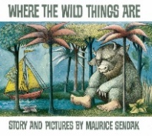  Where the Wild Things Are – Maurice Sendak | - Poetry – ‘when the Wind Blows’ by John Foster  - Narrative retell with embellishment  - Narrative retell with substitution
 | 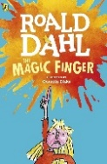  The Magic Finger – Roald Dahl | - Biography about Roald Dhal  - Poetry – compose own poem through substitution  - Narrative retell with embellishment  - Narrative retell with substation
Spring | 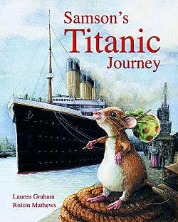  Samson’s Titanic Journey – Lauren Graham, Roison Mathews | - Poetry – List poem about the Titanic  - Fact file  - Non-chronological report  - Narrative retell  - Narrative embellishment
Summer | 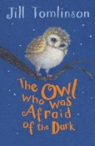  The Owl Who Was Afraid of the Dark – Jill Tomlinson | - Fact file – nocturnal animals  - Narrative retell and introduce a different nocturnal animal  - Poetry - Owl Chinquapin poem  - Recount – diary
 | 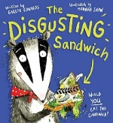  The Disgusting Sandwich by Hannah Shaw | - Narrative retell  - Narrative embellishment with substitution  - Non chronological report

Year 1
Term | Text | Genres
Autumn | 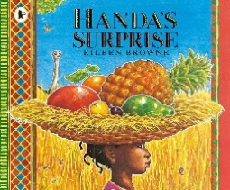  Handa’s Surprise – Eileen Browne | - Simple list poem  - Narrative retell  - Poems  - Narrative embellishment  Non-fiction texts about different animals.
 | 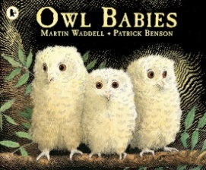  Owl Babies – Martin Waddell, Patrick Benson | - Poetry – Nursery Rhymes  - Narrative retell  - Non-chronological report – owls
Spring | 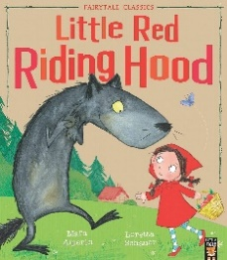  Little Red Riding Hood – Mara Alperin, Loretta Schauer and Jonathon Langley | - Poetry – List Poem  - Narrative retell  - Instructions – to make cakes for Grandma  - Non-chronological report – wolves
 | 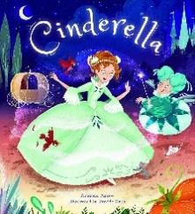  Cinderella – Story time Classics | - Poetry -  - Narrative retell  - Narrative embellishment
Summer | 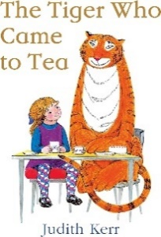  The Tiger Who Came to Tea – Judith Kerr | - Narrative retell  - Fact file  - Narrative innovation – the bear who came to breakfast  - Non-chronological report
Reception
Term | Text | Writing Opportunites
Autumn | 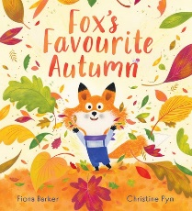  Funny Bones – Allan Alhberg Fox’s Favourite Autumn by Fiona Barker  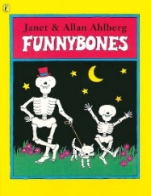 | - Labels  - Captions  - Sequencing  - Descriptive sentences.  - Retell  - Lists  - Instructions  - Non fiction writing
Spring | 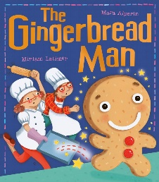  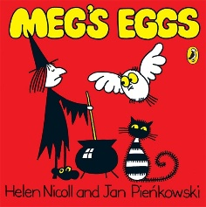  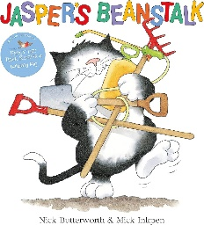  The Gingerbread Man Meg’s Eggs – Helen Nicoll Jasper’s Beanstalk – Nick Butterworth
Summer | Lost and Found – Oliver Jeffers Supertato – Sue Hendra, Paul Linnet  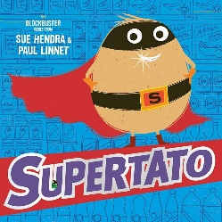  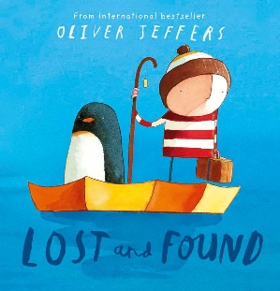

Nursery
Term | Text
Autumn | Peace at Last – Jill Murphy The Leaf Thief – Alice Hemming  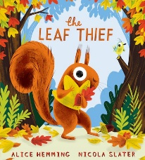  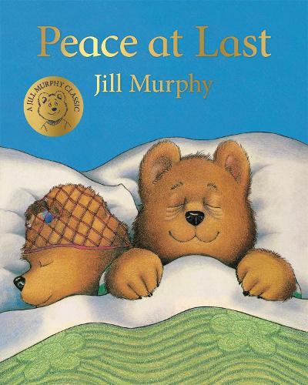
Spring | Goldilocks The Very Hungry Caterpillar  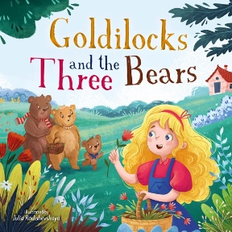  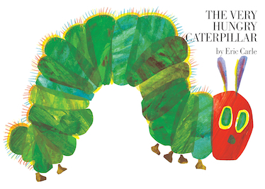
Summer | Elmer – David McGee Real Superheroes by Julia Seal  