



Etruscan Primary School

Behaviour
Management
Policy

Last Reviewed: March 2024

Review Date: March 2025

Behaviour Management Policy

At Etruscan Primary School we strive to secure a shared vision for all associated with our school community. Fundamentally we aim to provide a caring environment which seeks to promote the development of self-respect and respect for others through our school mission statement;

“Reach For The Stars”

- Aims

  - To promote the shared values of love, understanding, tolerance, justice and peace, in order to foster positive relationships within our school community.
  - To maintain a safe, harmonious environment which nurtures individuals by responding promptly to their needs, through active listening, keen observations and sincere interest and concern for all children.
  - To encourage self-awareness, openness and respect in the way we communicate and respond to others;
  - To establish an agreed code of behaviour, supported by clear and purposeful rules, rewards and sanctions, which are applied consistently by all.
  - To value and celebrate the effort and attainment of every individual whilst acknowledging diversity in relation to both academic and non-academic achievements.
  - To develop effective communication between parents/ carers, pupils and staff in dealing with disruptive behaviour in school.
  - To enable pupils to recognise and value their contribution and responsibilities, both within their school environment and wider community.
  - To promote a culture where both adults and children take responsibility for their own actions within a climate where self-esteem is fostered.

At Etruscan Primary School the expectation of high standards of behaviour for all pupils is fundamental to securing these objectives.
Within our school and wider community, all pupils and adults are encouraged to demonstrate courtesy, manners and respect for everyone. This framework of positive behaviour is based on the following values:

Respect for oneself, for others, for other people’s property and belongings
Enjoyment
Achievement
Collaboration
Honesty
These are our “REACH” values. Every conversation about behaviour is centred on these values. We expect all members of our school family to follow the values and to work together to make school a happy and safe place for everybody to learn in.

This policy is based on advice from the Department for Education (DfE) on:
- Behaviour and discipline in schools
- Searching, screening and confiscation at school
- The Equality Act 2010
- Keeping Children Safe in Education September 2021
- Use of reasonable force in schools
- Supporting pupils with medical conditions at school
- It is also based on the special educational needs and disability (SEND) code of practice.
- Schedule 1 of the Education (Independent School Standards) Regulations 2014; paragraph 7 outlines a school’s duty to safeguard and promote the welfare of children, paragraph 9 requires the school to have a written behaviour policy and paragraph 10 requires the school to have an anti-bullying strategy
- DfE guidance explaining that academies should publish their behaviour policy and anti-bullying strategy online
- This policy complies with our funding agreement and articles of association.

2. Rules, Expectations and Standards

Within the above framework, a set of clear rules and expectations have been negotiated with the Local Governing Board, staff, pupils and parents/carers in order to establish an agreed code of behaviour in school. Children negotiate and agree expectations for behaviour in class at the beginning of each academic year. Similarly, an agreed code of behaviour in the dining hall has been established with midday supervisors and all pupils. This is shown on the interactive whiteboard in the hall regularly during lunchtimes. The following list contains some examples of school rules and guidelines for children:

- Follow the school values
- Always work hard, give your best in school and finish tasks you have been given.
- Wear correct uniform – be smart and tidy.
- Show respect towards others, yourself and the environment.
- Speak quietly and politely, using good manners at all times.
- Offer to help others, where possible.
- We have kind hands, kind feet and kind words.
- Walk at all times, when inside the school building and off-site.

3. Uniform

The wearing of correct uniform is considered to be an important part in establishing a sense of community and standards in school. Children are encouraged to take pride in wearing appropriate uniform, including PE kit. Shoulder length hair should be tied back at all times. Stud ear-rings may be worn in school but are required to be removed for P.E. It is important to note that school staff are not permitted to remove ear-rings.

4. Roles and Responsibilities

It remains the overall responsibility of the Headteacher, Deputy Headteacher, Assistant Headteacher and the leadership team to ensure that high standards of behaviour are maintained on a daily basis. However, at Etruscan Primary School we acknowledge the responsibility of every person - adult and child - in promoting and maintaining high standards of behaviour at all times.

4.1 School Council

Two representatives from each class in Reception to year 6 meet with Miss Grocott each half term, or more often if necessary, to discuss matters on an agreed agenda and any issues relating to school life which have been brought to their attention by children in their class. Minutes of the meetings are recorded and stuck into the class School Council books. Representatives from the School Council, one boy and one girl from each class, are elected democratically. They are expected to gather the views of the children in their class on issues to be discussed at the meetings and are also expected to provide prompt feedback to their class. The School Council are responsible for arranging an annual anti-bullying week to raise awareness of what bullying is and what children, staff and parents/carers can do about it if they or somebody they know are being bullied. They also work on raising school attendance, represent the school at events and raise funds for school and for agreed charities.

4.2 Prefects

Prefects are selected from children in Year 6 and Year 5. Prefects are selected following a presentation from each candidate. Prefects have a range of duties around school, including monitoring behaviour in the corridors, on the stairs and in the hall at lunchtime.

4.3 Playground and Friendship Buddies

Children in year two can apply to be Playground Buddies and in years 4 and 6 can apply to be Friendship Buddies. Children are selected following an interview with the Learning Mentor. The role of the Friendship and Playtime Buddies is to promote friendships on the playground. They are trained and lead by the Learning Mentor.

5. Classroom Management

Teachers and support staff should;

- Follow the staff Code of Conduct
- Adhere to the Behaviour Management policy at all times
- Adhere to the Anti-Bullying policy at all times
- Promote good behaviour by using praise and rewards
- Make sure that they are always present to supervise children in the classroom
- Prepare materials and equipment before each lesson
- Make sure all children have access to materials and equipment during lessons
- Ensure that children complete assigned tasks
- Display classroom rules and school values clearly in the classroom.
- Choose and display the “star of the week”, with positive comments about that child from other members of the class
- Actively teach the class rules and the school values to the children
- Use praise and rewards to encourage children
- Refer to the class rules and school values in praise and sanctions
- Be consistent in response to infringement of classroom rules
- Speak quietly to model appropriate behaviour to children
- Refer any children who are continually disruptive to the Learning Mentor

6. Movement around the corridors, stairs and to the mobile classroom

Teachers, support staff and prefects to-

- Make sure that children walk sensibly in the corridors and on the stairs.
- Ensure that children are supervised as they move through the school throughout the day, at the beginning and end of the day and break time / lunchtime
- Make sure that children always walk on the left side of the corridors.

7. Fair Rules

7.1 Whole School

We will :-
- Provide and maintain a friendly, encouraging, secure, supportive and positive school environment in which all can learn
- Provide a pleasant and safe environment for all members of the school community
- Know our school values and make sure they are consistently applied across the school

At no time will anyone do anything that causes harm, offence, inconvenience or unnecessary work for other members of the school community.

8. Practice and Procedures

8.1 Rewarding Achievements and Behaviour

The following methods will be used by adults to reward positive behaviour, good work, demonstration of school values or acts of good citizenship;

- Positive acknowledgement or comments to individuals or groups
- Visual prompts within classrooms to highlight individuals for good behaviour, eg. badges, stickers
- The use of stickers and/or team housepoints on a class record
- Star of the week award displayed in the classroom with peers’ positive comments about the child written on it
- Headteacher awards, prizes and stickers for exceptional work, improvement or behaviour
- Children receive a ‘you’ve been spotted’ sticker and raffle ticket for displaying good citizenship, school values or British values which are placed in a draw to win a prize in the weekly Star Worship assembly
- A ‘Star Award’ certificate is given to one child each week in every classroom to celebrate their achievements, which may or may not be for academic achievement. good behaviour at lunchtime
- Attendance awards for the class with best overall attendance each week and for individuals each half term and at the end of the school year
- Attendance certificates, awarded on a half termly basis
- The “Kettle Cup” is awarded to one child from Year 6 each year for an outstanding contribution to school life
- A variety of awards are presented for a range of successes and achievements, including those listed above and raffle tickets, prize draws, notes home

8.2 Sanctions for inappropriate behaviour

The right of every child to fully access a broad, balanced curriculum through quality learning and teaching experiences is fundamental in ensuring the highest standards of behaviour are maintained within every classroom. Procedures for minimising disruptive behaviour include the planning and delivery of high quality learning experiences, matched to individual needs and abilities, in order to sustain and motivate pupils to learn and achieve. Staff are entrusted to manage inappropriate behaviour promptly and effectively, in accordance with school policy.

Sanctions should be:-

- Used to discourage repetition of inappropriate behaviour
- Given immediately (or as soon as possible) after the undesired behaviour
- Focused on the behaviour, not the person
- Appropriate to the deed
- Perceived as undesirable by the recipient
- Applied to the chid who has demonstrated the inappropriate behaviour and never to a group/class

When applying sanctions teachers should:

- Follow the consequences in the behaviour policy
- Refer to the school values where appropriate
- Discuss the inappropriate behaviour with the child and discuss the impact of their actions on others, where appropriate
- Involve the child in negotiating their own sanctions
- Remain calm and non-emotive
- Help the child to explain what behaviour is required
- Restore relations as soon as possible
It is important to state that at Etruscan we consider that ‘EACH DAY IS A FRESH START’

The range of consequences are as follows:

1st reminder No additional consequences

2nd reminder Child works on a different table/ on their own for 10 minutes, then returns to place

3rd reminder Child works in a different room – pre-arranged (see appendix 2) and child takes work for the rest of that lesson

4th reminder Child sent to Headteacher who advises that if they break the rules again then parents/carers will be informed.

5th reminder Parents/carers informed.

(See appendices one and five- behaviour prompt sheets)

When on the playground, the range of consequences are as follows:

1st reminder Verbal, no additional consequences

2nd reminder Child stands out of the game, on the side of the yard for five minutes.

3rd reminder Child is sent in to a member of SLT. Children may be recorded in the behaviour book

If the child has had three reminders in one day, their names are recorded by the class teacher on the 3
warnings form (see appendix 4). If the child regularly receives 3 warnings, they are spoken to by the Headteacher and their parent/carer may be contacted.

If the child has been in the behaviour book three times or more, their parents/carers are informed and asked
to come to school for a meeting. Parents/carers are also informed by telephone or in a meeting when their
child’s behaviour has improved. All behaviour data is collated, tracked and analysed by the Headteacher
each half term and summarised at the end of the academic year.
It is reported to the Local Governing Board at termly Etruscan Committee meetings.

8.3 Behaviour Reviews

If a child has been in the behaviour book, their behaviour is reviewed by the Headteacher after two weeks.
In the review the class teacher and the child are asked how the child’s behaviour has improved (see appendix
3) and the child is praised if their behaviour has improved.
If it has not improved, the child is asked what they need to do to improve it and parents may be informed.

8.4 Learning Mentor

For a very small minority of children, these sanctions will not be appropriate due to behavioural, emotional or social difficulties. The SENCo is then informed and a Learning Mentor referral may be made. These children are then assessed using a Boxhall Profile and an individual behaviour plan may be put in place. The SENCo and Learning Mentor track the progress of the children and report back to the Headteacher and parents/carers.

8.5 Outside Agencies
If a child is persistently disruptive, support from outside agencies, for example Inspire SEND services or CAMHS, may be sought.

8.6 Fixed term Suspension
In exceptional cases, the Headteacher may authorise a fixed term suspension. A decision to suspend a child for a fixed period is taken in response to breaches of the Behaviour Policy, including persistent disruptive behaviour, where these are not serious enough to warrant permanent exclusion and lesser sanctions are considered inappropriate. Individual fixed term suspension should be for the shortest time necessary.
8.7 Permanent Exclusions
Permanent exclusion is extremely rare and will only be used:
• In response to serious breaches of the Behaviour Policy.
• In response to serious breaches of the Drugs, Alcohol, Tobacco, Illegal and Controlled Substances Policy.
• If allowing the child to remain in the school would seriously harm the education or health, safety and welfare of the child or others.
The decision to exclude a child permanently is a serious step and will only be taken when the full facts have been clearly established. It is the final stage in a process for dealing with breaches of the Behaviour Policy following a range of other strategies which have been tried without success. When all available strategies have been exhausted without success, a permanent exclusion will be used as a last resort.
There will, however, be exceptional circumstances when, in the Headteacher’s judgement, it is appropriate to permanently exclude a child for a first or ‘one off’ offence. These might include, for example:
• Serious actual or threatened violence against another student or member of staff.
• Sexual abuse or assault.
• Carrying or supplying an illegal drug/alcohol (refer to the Drugs, Alcohol, Tobacco, Illegal and Controlled Substances Policy).
• Carrying an offensive weapon.

8.8 Management of Exclusions including Fixed Term and Permanent Exclusions
Procedures for managing exclusions will strictly follow the DfE guidance,
‘Improving behaviour and attendance: guidance on exclusion from schools and Pupil Referral Units, September 2012’.
Fixed Term
The school adheres to the DfE regulations regarding exclusions at all times. Following an exclusion parents/carers will be contacted immediately where possible. A letter is sent by post giving details of the exclusion and the date the exclusion ends.
Parents/carers have a right to make representations to the Local Governing Body as indicated in the exclusion letter. A reintegration meeting will be held if applicable, following the expiry of the fixed term exclusion and this will include the child, parent/carer, teacher and other staff where appropriate. During a fixed term exclusion where the child is to be at home, parents/carers are advised that the child is not allowed on school premises, and the daytime supervision is the responsibility of parents/carers. The school will provide suitable alternative provision for a fixed term exclusion of 6 days or longer. The details of this will be included in the exclusion letter.
Permanent Exclusions
Following the decision to permanently exclude, parents/carers, the Local Authority and the Local Governing Body will be informed immediately. A letter will be sent by post giving details of the exclusion. A meeting must be held by the Local Governing Body to consider the exclusion within 15 school days of the date of the exclusion. Parents/carers, the Headteacher and a representative from the Local Authority will be invited and allowed to make representations. Parents/carers may be accompanied by a friend or representative if they wish.
In accordance with DfE guidance, the Local Authority will provide education from the sixth day of a permanent exclusion.
The Local Governing Body will notify parents, the Headteacher and the Local Authority of their decision and reasons for their decision in writing without delay. The letter will include all information regarding the parents’ rights to ask for the decision to be reviewed by an Independent Review Panel as detailed in the DfE Guidance.
The permanently excluded child will be removed from the school’s roll if 15 schools days have passed since the parents/carers were notified of the local Governing Body’s decision to uphold the permanent exclusion and no application has been made for an Independent Review Panel.

8.9 Physical Containment

On rare occasions there is no alternative to restraining pupils physically, in their and others’ interests and safety. In such circumstances no more than minimum force should be used, taking all of the circumstances into account (hold from behind and hold wrists whilst telling the child that they are being restrained until they are calm). Such interventions should be made only when they are likely to succeed. Desirably more than one adult should be present (although this is not always possible). Physical restraint is normally only used to prevent a pupil causing harm to him or herself or to others, seriously damaging property, or committing some criminal act which risks harm to people or property, when verbal commands will not control the behaviour. The purpose of intervention is to restore safety, and restraint should not continue for longer than is necessary. Physical contact and restraint should never be used in anger and teachers should seek to avoid any injury to the child. They are not expected to restrain a child if by doing so they will put themselves at risk. Brief periods of withdrawal away from the point of conflict into a calmer environment may be more effective for an agitated child than holding or physical restraint. All instances of physical restraint are recorded and reported to the Headteacher. Please see our Physical Restraint policy.

9. Leaving the premises without permission

School is secure and gates are locked at all times. However, should a child try to leave the premises an attempt will be made to persuade them not to leave the school grounds. If they do leave, a member of staff will immediately report the incident to the Headteacher and to the school office who will contact the child’s parents/carers and the police if deemed necessary.

10. Roles and Responsibilities

10.1 Responsibilities of class based staff

- Have high expectations for behaviour and behaviour for learning

- Follow the staff Code of Conduct; model good behaviour and respect to others

- Adhere to the Behaviour Management policy and display the behaviour prompt chart (appendices 1 and 5)

- Make school values and classroom rules, rewards and sanctions clear to pupils from the first lesson and explain why they are necessary

- Avoid the punishment of whole groups

- Use PSHE and RE lessons to promote desired behaviour and to open discussions about negative behaviours

- Apply fair and consistent strategies which make the distinction between serious and minor offences apparent

- Plan and organise both the classroom and lesson to keep pupils interested and thus to minimise the opportunity for disruption

- Emphasise the positive, including praising good behaviour, effort and acts of good citizenship as well as work

- Know that the school has a zero tolerance policy to bullying, be alert to signs of bullying (including cyber bullying, prejudice-based bullying and discriminatory bullying) and take action based on clear rules established to help and protect children (see Anti-Bullying Policy)

- Know that the school has a zero tolerance policy to child on child abuse, be alert to signs of child on child abuse (including sexism, sexual harassment and sexual violence,) and take action based on clear rules established to help and protect in time (see Peer on Peer Abuse Policy)

- Involve parents/carers at an early stage rather than as a last resort

- Report improvements in behaviour to parents/carers

- Be strategically placed when children are leaving the premises and when they are moving from the playground to the classroom or other areas in the school

- Use the agreed school system of record keeping and pupil profiles to identify potential learning and behavioural problems at an early stage.

- Be accessible, where possible, to parents/carers outside formal parent/carer consultation evenings to work in partnership to ensure positive behaviour

10.2 Responsibilities of the Leadership Team

- Ensure that the school's behaviour policies are communicated clearly and fully to parents/carers, are published on the website and that regular reminders are given as well as informing them of any major changes

- Ensure an effective induction system for parents of new pupils, including setting out behaviour expectations

- Use all means to build up a sense of community in the school which encourages the active participation of the Local Governing Body members, staff, parents/carers and pupils

- Take the lead in defining the aims and values of the school with particular reference to standards of behaviour

- Use assemblies to promote desired behaviour and to praise good behaviour

- Ensure that there are effective channels of communication within the school and between the school and the parents/carers, the community and outside agencies

- Encourage the staff by recognising and praising their efforts and achievements

- Have a clear system for reporting any staff not adhering to the Code of Conduct, referring any safeguarding concerns into the Local Authority designated Officer if needed. Keep a log of low level incidents which do not meet the LADO threshold, including actions taken

- Follow HR advice for staff accused of misconduct, providing pastoral care if needed and/or appropriate

- Inform the Local Governing Body on the standards of behaviour in the school through termly behaviour analysis reports by the Headteacher to the Etruscan Committee

- Ensure by consistent and democratic policy making and support that all staff accept responsibility for maintaining good behaviour throughout the school

- Ensure that mid-day supervisors are given adequate training in the management of pupils' behaviour, that they are supported by the SLT and are recognised as an important part of the school community

- Develop an active partnership with parents/carers and staff as an aid to promoting good behaviour

- Inform parents/carers of their child's positive behaviour and work

- Complete behaviour reviews 2 weeks after a child has been put in the behviour book

Involve parents/carers by:-

- Establishing good channels of communication, incorporating a fortnightly newsletter and access to teachers for parents/carers wishing to discuss their children

- Providing a welcoming and inclusive environment for parents

- Using parents/carers as helpers in the classroom for individual and small group work, subject to DBS checks

10.3 Responsibilities of Parents/Carers

It is expected that parents/carers will share the school's desire to create a calm, orderly and caring environment in which children can develop and learn and that they will share and support the school's policy of courtesy and respect for others. The home-school agreement, completed on induction sets out parents’/carers’ responsibilities towards developing good behaviour and positive attitudes in their children.
11. Off-site behaviour
Sanctions may be applied where a pupil has misbehaved off-site when representing the school. This means misbehaviour when the pupil is:
- Taking part in any school-organised or school-related activity (e.g. school trips)
- Travelling to or from school
- Wearing school uniform
- In any other way identifiable as a pupil of our school
Sanctions may also be applied where a pupil has misbehaved off-site at any time, whether or not the conditions above apply, if the misbehaviour:
- Could have repercussions for the orderly running of the school
- Poses a threat to another pupil or member of the public
- Could adversely affect the reputation of the school
Sanctions will only be given out on school premises or elsewhere when the pupil is under the lawful control of the staff member (e.g. on a school-organised trip).

12. Malicious allegations
Where a pupil makes an allegation against a member of staff and that allegation is shown to have been deliberately invented or malicious, the school will discipline the pupil in accordance with this policy.
Where a pupil makes an allegation of sexual violence or sexual harassment against another pupil and that allegation is shown to have been deliberately invented or malicious, the school will discipline the pupil in accordance with this policy.
In all cases where an allegation is determined to be unsubstantiated, unfounded, false or malicious, the school (in collaboration with the Local Authority Designated Officer, where relevant) will consider whether the pupil who made the allegation is in need of help, or the allegation may have been a cry for help. If so, a referral to children’s social care may be appropriate.
The school will also consider the pastoral needs of staff and pupils accused of misconduct.
Please refer to our child protection and safeguarding policy.
13. Searching and screening
The headteacher, or someone who has the authorisation from the headteacher, can search a pupil or their possessions where they have reasonable grounds to suspect that the pupil may have one of the items listed below. Possessions include the child’s coat, bag, desk, or tray. Before any search takes place, the member of staff conducting the search explains to the child why they are being searched, how and where the search is going to take place and gives them the opportunity to ask any questions. Parents/carers are also informed. The search is conducted in an appropriate location, with 2 members of staff being present. If the search requires a child to be searched (for example, their pockets) then the parents/carers are informed and attend the search. If the search must happen imminently as the headteacher feels the child, other pupils or staff are at high risk then the search will take place in a suitable location away from other pupils. The child can only be asked to remove their outer clothing (coat, scarf, hat, gloves). If an item has been found, then the Designated Safeguarding Lead, parents/carers and potentially the police, are informed.
• mobile phone
• knives or weapons
• alcohol
• illegal drugs
• stolen items
• any articles that the staff reasonably suspect have been or is likely to be used: to commit an offence, to cause personal injury, damage of property
• tobacco and cigarette papers
• lighters/matches
• e-cigarettes and vapes
• fireworks
• pornographic images
After a search has been completed a record of the search is kept. This must include:
• date, time, location of the search
• pupil’s name
• reason for the search
• who was present at the search
• what was being searched for
• what was found, if anything
Follow up action/consequence of the search.

Parents are informed of the outcome of the search. If a controlled drug or something which the staff member deems to be a harmful substance or weapon is found, the police must be contacted. This includes any weapons which may have been used to commit a suspected offence. Staff should dispose safely of other items including alcohol, tobacco, cigarettes, e-cigarettes, vapes, matches, lighters or fireworks in a safe manner and these should not be returned to the pupil. If a pornographic image is found the police and the parent/carer must be informed. If a stolen item is found it may be returned to the owner, the parents/carers informed and the police informed if the headteacher deems it necessary. All electronic devices should be passed to the headteacher.

14. Final Points

Under no circumstances should:

A pupil be made to stand outside a classroom or the staffroom unsupervised

Any form of corporal punishment be used

A teacheror support staff leave a class unsupervised

A whole group be punished for the actions of a few

15. Bullying and Harassment

Bullying is defined by the DfE as ‘deliberately hurtful behaviour repeated often over a period of time’

Bullying, including cyber bullying, or harassment is unacceptable behaviour and this is made clear to all children and staff. Bullying affects self-esteem, well-being, happiness and mental health. It can affect children’s ability to concentrate and make them anxious about attending school. We encourage children and parents/carers to tell staff of problems or incidents as they arise so that they can be dealt with appropriately. Children are regularly informed through work in the classroom and whole school worship of how to deal with situations if they feel they are being bullied and we have an annual whole school anti bullying week which is planned by the School Council.

Bullying can include:-
- Name calling
- Being teased
- Being hit, punched, pulled or kicked
- Having possessions taken
- Receiving abusive messages via text, email or other forms of technological communication
- Being forced to hand over money
- Being forced to do things they don’t want to do
- Being ignored or left out
- Being attacked because of religion, gender, sexuality, disability, appearance or racial origin.
Please see the Anti-Bullying policy for more details

16. Role of the Local Governing Body and Board of Trustees

The role of the Local Governing Body and Board of Trustees is to challenge and support the Senior Leadership Team in carrying out the roles and responsibilities outlined in this policy.

17. Links with other Policies

This policy links closely with other school policies as follows:

- Anti-Bullying
- Accessibility and Equality Scheme
- E-Safety
- Dealing with Vexatous Parents/ Carers
- Physical Restraint
- SEND
- Attendance

Signed………………………………………………………

C Crook
Headteacher

Signed………………………………………………………

Julie Thompson/Laraine Jones; co-chairs of governors

Date…………………………………………………

Appendix one- behaviour prompt sheet

If you make the wrong choices, this is what will happen:-

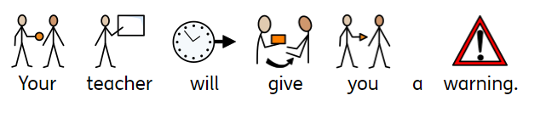
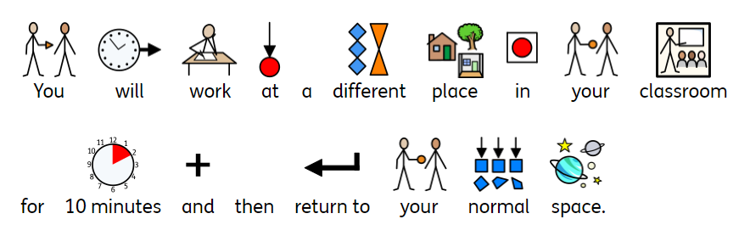
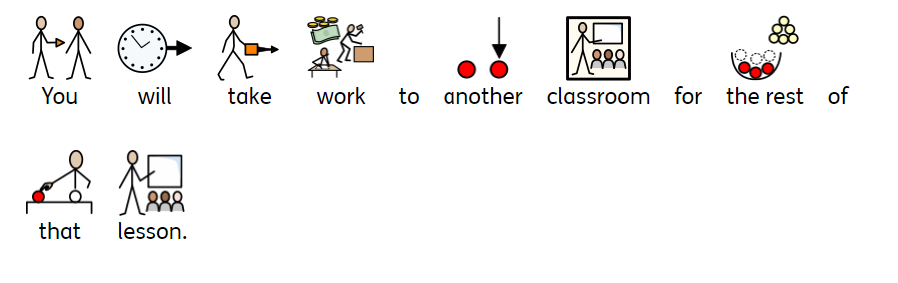
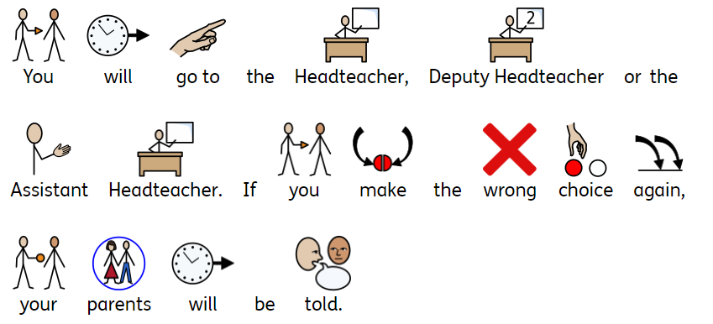
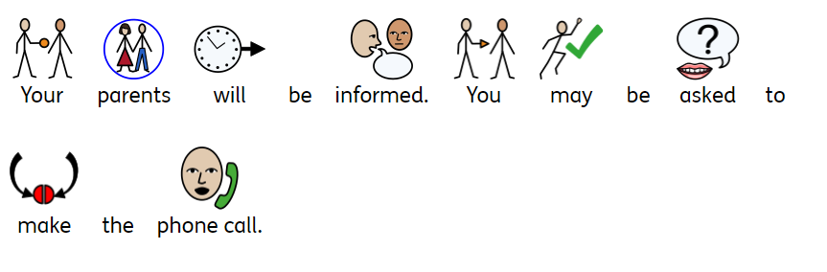

EACH DAY IS A FRESH START

In nursery, if you make the wrong choices, this is what will happen:-

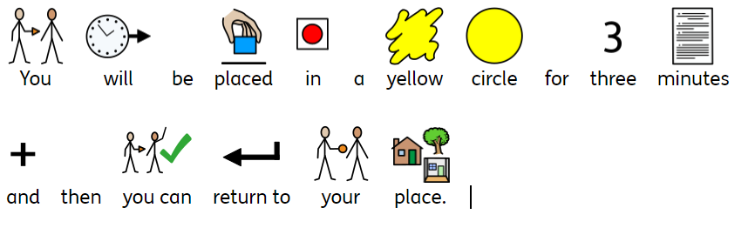
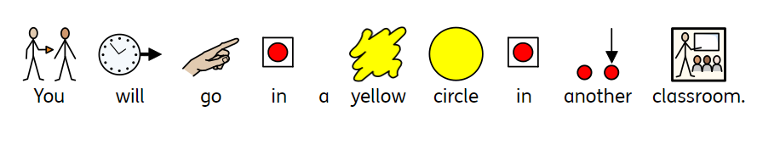

EACH DAY IS A FRESH START

In reception, if you make the wrong choices, this is what will happen:-

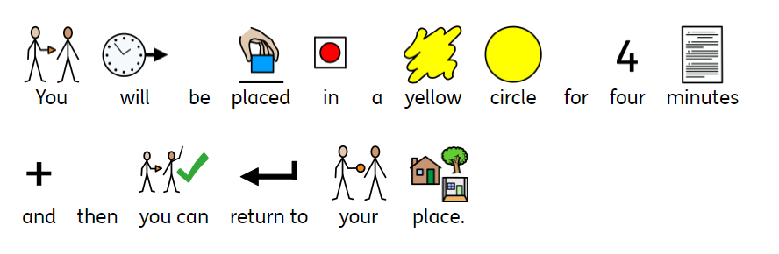

Appendix 2- Buddy classes



Buddy Classes

Year 6 | Hayley Goodwin
Year 5 | Karla Thorley
Year 4 | Karla Thorley
Year 3 | Laura Tranter
Year 2 | Laura Tranter
Year 1 | Hayley Goodwin

Appendix 3- Behaviour Review Form

Etruscan Primary School
Behaviour Review
Date | Name
Any further incidents?

Child’s view:

Class teacher’s view:

Any interventions and impact:

Next steps:

Appendix 4- 3 warnings form
Year_____________

Children receiving 3 warnings/ removal from class
Date | Name | Reason | Follow up

Appendix five- Foundation Stage behaviour prompt sheet

