

Marking Policy

Completed: December 2023

Review: December 2025

# **Rationale**

*‘Feedback is one of the most powerful influences on learning and achievement’*

(Hattie and Timperley 2007)

*‘Feedback plays a central role on securing student’s learning, supporting them how to deepen their knowledge and understanding or improve their performance’*

(Teaching Walkthrus Tom Sherington and Oliver Caviglioli)

*‘Effective marking is an essential part of the education process. At its heart, it is an interaction between teacher and pupil: a way of acknowledging pupils’ work, checking the outcomes and making decisions about what teachers and pupils need to do next, with the primary aim of driving pupil progress.*’

(Report of the Independent Teacher Workload Review Group)

All forms of marking and feedback are crucial to the success of children. It is to close the gap between what they know and what they do not know or to fill the gap between where they are and where they are going. Marking and feedback in the moment is a vital form of communication between child and teacher/teaching assistant. It enables children to become reflective learners and helps them to close the gap between what they can currently do and what we would like them to be able to do. It

is part of the Assessment process in that it gives both the teacher and pupil an opportunity to identify strengths and weaknesses.

For feedback to be effective John Hattie argues that it needs to be:

* clear, purposeful, meaningful and compatible with pupils’ prior knowledge, and to provide logical connections.
* directed at the right level, so it can assist students to comprehend, engage, or develop effective strategies to process the information intended to be learnt.”
* combined with effective instruction in classrooms, and focus on what is being learnt (learning objective) and how students should go about it (success criteria)
* occur as the pupils are doing the learning
* provide information on how and why the pupil has or has not met the criteria
* provide strategies to help the pupil to improve

# **Marking and Feedback at Etruscan Primary School**

At Etruscan, we believe that the process of marking and offering incisive feedback should be provided in the moment, it is a dialogue that takes place between teacher/teaching assistant and child, ideally while the learning is still being completed.

Teachers and teaching assistants should promote children's self/peer-assessment into a wider process of engaging the child in his or her own learning and developing their ability to self scaffold their learning.

Whenever possible, marking and feedback should involve the child directly. The younger the child, the more important it is that the feedback is oral and immediate.

Feedback in the moment will help a child to identify their key priorities for improvement and the progress they are making towards personal targets.

Teachers will ensure that understanding is checked systematically when marking in the moment and they will swiftly adapt their teaching accordingly.

# **Marking and Feedback**

|  |  |
| --- | --- |
| Marking | Purpose |
| Marking in the Moment | Intervention marking within the lesson to prompt deeper thinking, and swiftly address misconceptions. This takes the form of verbal feedback and occurs through effective questioning to clarify or refocus tasks and enquiry, mini plenaries and mid-lesson adjustments or written feedback where misconceptions are remodelled or challenges provided. |
| Improvement Marking | Verbal feedback will be given to the children and an opportunity to respond will be given in order to strengthen the teaching and learning process to accelerate and deepen learning. |
| Self-assessment and peer assessment | Autonomy is given to the children. Differentiated success criteria is used to comment on the attainment and success of a piece of work and suggestions for improvement, indicating positive ways forward. Teachers will acknowledge the marking completed by the children |
| Learning Acknowledgement | All learning outcomes will be acknowledged at the end of the lesson. It is essential that all learning produced by a child is valued and their efforts and outcomes are acknowledged against the intended learning outcome. Strategies for self-regulation should explicitly taught to enable children to identify their own mistakes and correct accordingly. |

During the lesson, teachers and all additional adults will effectively intervene in the moment and give feedback, verbally and in-the-moment remodelling of misconceptions, consolidating learning or moving the learning forward. This should be quick and remain positive encouraging a Growth Mind-set, resilience, striving for accuracy and children’s learning efforts. Teachers and additional adults will effectively intervene with groups across the class giving immediate feedback on the children’s work. Marking in the moment in the forms of ticks to indicate correct answers across the school curriculum and areas for improvement, or identified mistakes, should be pointed out to the children within the lesson to enable children to take greater ownership to correct through self-regulation.

|  |
| --- |
| When Marking ‘In the Moment’ |
| Titles are checked and children are given the opportunity to correct if copied incorrectly or not underlined. |
| Marking is focused upon lesson objectives and success criteria (adapted accordingly) |
| Verbal feedback to children will provide opportunities to self-regulate, address misconceptions in the moment and move their learning forward through opportunities that lead to depth in knowledge and understanding. This is indicated using ‘VF’ in the margin at the point where it was given. |
| Marking and marking sheets are to be done in a clear legible handwriting using the school’s handwriting policy or typed. |
| Marking is used to support the day-to-day assessments of learning so that difficulties are identified immediately and misconceptions can be addressed in the lesson. |

Across all lessons, there should be a greater emphasis on ‘In the Moment’ marking, however sometimes, for whatever reason staff will be unable to mark in the moment or there is some work that has not been marked in the moment.

|  |
| --- |
| When staff have been unable to Mark ‘In the Moment’ All learning will be acknowledged in full. |
| Titles should be checked to ensure that habitual errors are not being made. |
| The content of the learning should all be read in detail and checked against the lesson objectives and success criteria (adapted accordingly) for accuracy. |
| Marking is used to support the day-to-day assessments of learning so that difficulties are identified and misconceptions can be used to plan future lessons accordingly. |
| Marking should identify punctuation, grammar and spelling mistakes. |
| On occasions, it may be suitable to write a positive individual comment in the child’s book.  Never write a negative comment in child’s book. |

All marking and feedback to be done in black ink.

**LO and SC**

Nursery to Year 1

|  |  |  |  |  |  |  |  |
| --- | --- | --- | --- | --- | --- | --- | --- |
| Finger spaces | Phonics | Letter formation | A  Capital letter | .  Full stop | ?  Question mark | !  exclamation mark | ,  Comma |
| Adjectives | Conjunction | verbs | http://images.clipartpanda.com/house-door-clipart-door-clip-art-door-clip-art-8.png  Openers | **FANBOYS**  Coordinate  Subordinate | SP  Spelling |  |  |

|  |  |
| --- | --- |
| Marking of mathematics | Reception- Year 6, indicate an error with ..  Use ticks to show that the work is correct. Do not use x or ☹. |
| Marking of all other subjects. | In Year 1 and Year 2 – correct only handwriting and spelling. Grammatical errors should be addressed during the whole class feedback. See marking code progression section.  In all subjects, Year 2 HA, Years 3 – 6 aside from spellings and letter formation/joins, all other errors will be recorded using a . in the margin. This will tell the child that there is an error on that line and they must decide what it is and correct it.  Use ticks to show that the work is correct. Do not use x or ☹. |

**Whole Class Marking Sheets Year 1 – 6**

After each lesson, a whole class marking feedback sheet should be completed.

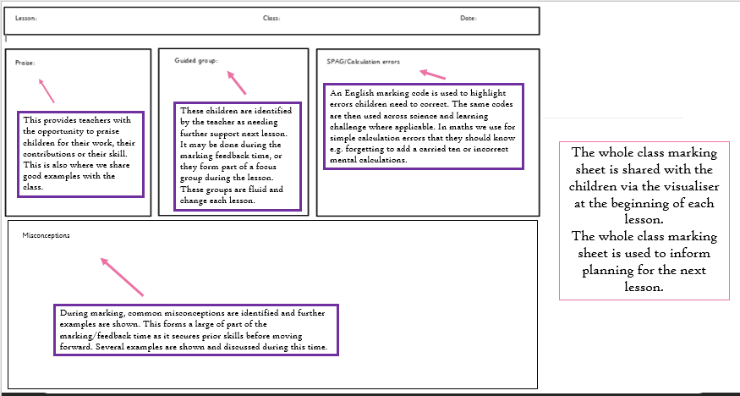

* Successful examples should be shared under the visualiser or read aloud to the class.

**Marking code progression**

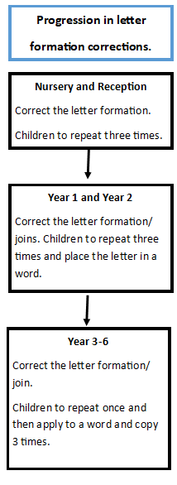

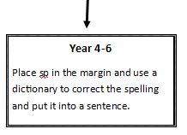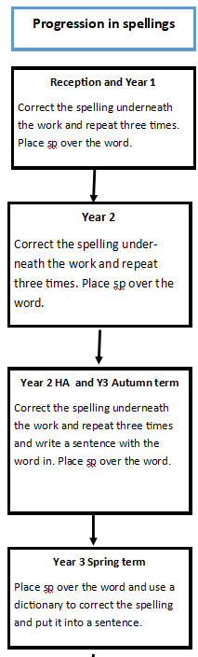

**‘**

**‘Fix it’ time**

* Nursery – Year 2 will make their corrections in pencil underneath the piece of work.
* Year 2HA – Year 6 children will complete the ‘fix it’ in blue ball point pen. They will rub out the error and correct it.

**Identifying the level of support given to the child:**

From Nursery to Year 6, use the codes below to indicate the level of support provided.

* G – group work
* I – independent
* w/s – worked with support
* P – partner
* VF – verbal feedback given

# **Role of Other Adults Supporting Marking and Feedback**

All staff in the classroom are expected to mark in the moment, this will support children in receiving immediate feedback which they can respond to.

**Special Educational Needs and Disabilities**

When marking the work of children with Special Educational Needs and Disabilities, we take into account the wide range of abilities of our children. Children’s individual education plans will be used to support when marking and giving feedback. Extra support is given and the curriculum is differentiated to meet their individual needs, whilst ensuring access to a full and varied curriculum along with their peers.

Appropriate adjustments will be made so that every SEND child can fully access the curriculum and will be given feedback appropriate to their learning.