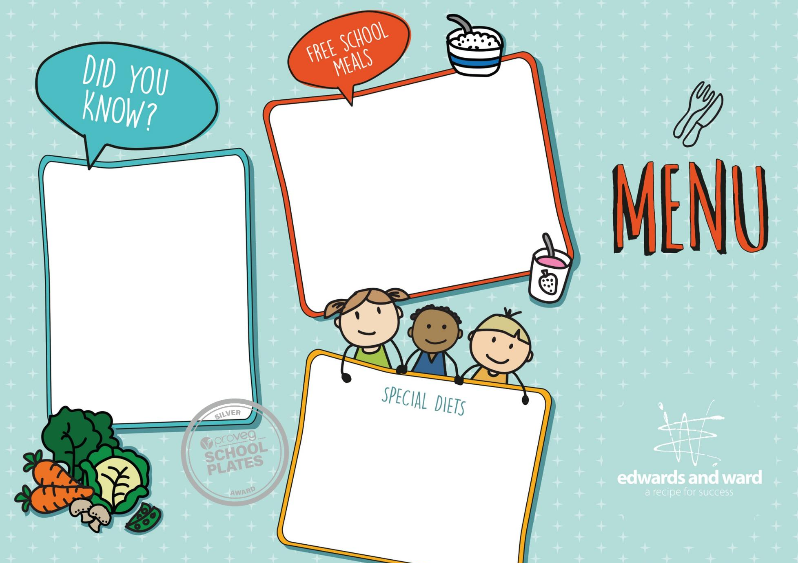



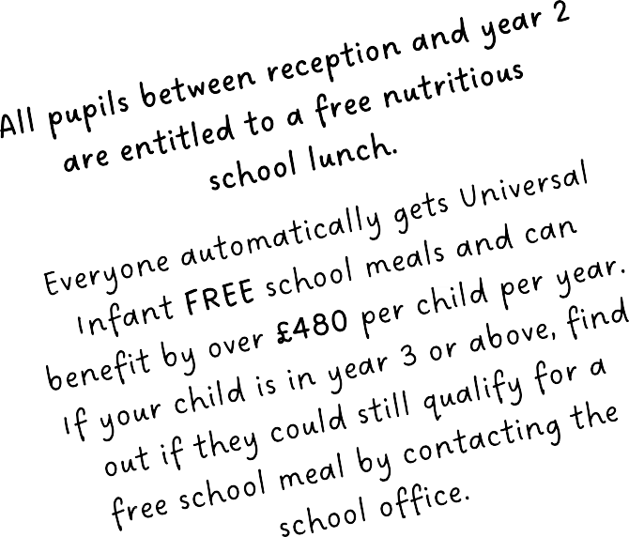
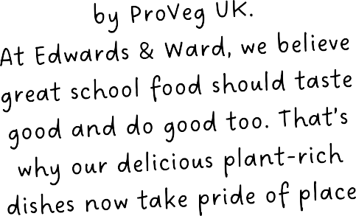


Autumn/Winter 2026-27





Fajita Pizza with Purple Slaw (V) or Fiesta Beany Burrito with Rice (Ve) Veg of the Day  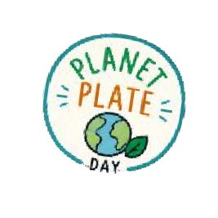  Banoffee Mousse (V) | Margherita Pizza with Jacket Wedges (V) or Rainbow Vegetable Chow Mein (Ve)  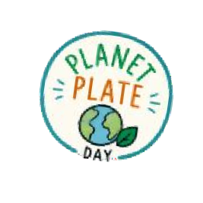  Veg of the Day Cinnamon Swirl (Ve) | Superhero Pizza with Paprika & Garlic Potatoes (V) or Sunshine Sweet Potato Curry with Rice (Ve)  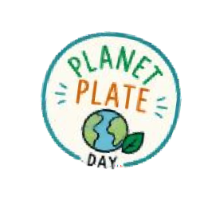  Veg of the Day Cinnamon Apple Whirl (Ve)
Creamy Cauli & Chickpea Curry with Rice (Ve) or Penne with Beef Bolognese  Veg of the Day Vanilla Shortbread (Ve) | Penne with Garden Bolognese (Ve) or Golden Chicken Curry with Lemon Rice  Veg of the Day Pinwheel Biscuits (Ve) | Penne with Garden Bolognese (Ve) or Creamy Cauli & Chickpea Curry with Rice (VE) Veg of the Day  Chocolate Snap (Ve)
Cheese Oatcake with Roasties (V) or Plantastic Meatballs with Roasties & Gravy  Veg of the Day Apple Flapjack (Ve) | Sage & Onion Whirl with Roasties & Gravy (Ve) or Cheese Oatcake with Roasties & Gravy Veg of the Day  Flapjack (Ve) | Roast Chicken with Stuffing, & Roasties or Cheese Oatcake with Roasties  Veg of the Day Soft Baked Cookies (V)
Mighty Hero Mac & Cheese (V) or | BBQ Mac & Cheese (V) or | Classic Mac & Cheese (V) or
BBQ Chicken Melt with Sunshine Rice | Texas Beef Chilli Burrito with Crunchy Slaw | Golden Chicken Curry with Lemon Rice
Veg of the Day | Veg of the Day | Veg of the Day
Rich Pear & Chocolate Sponge (V) | Golden Apple Cake (V) | Topsy-Turvy Pineapple Cake (V)
Cheesy Bean Whirl with Chips (V) or | Crispy Quorn Nuggets with Chips (Ve) or | Crispy Garden Fingers with Chips (Ve) or
Crispy Battered Fish with Chips | Chicken Nuggets with Chips | Fish Fingers with Chips
Veg of the Day | Veg of the Day | Veg of the Day
Fruity Jelly (Ve) | Fruity Jelly (Ve) | Fruity Jelly (Ve)
31/8/26, 21/9/26, 12/10/26, 2/11/26, 23/11/26, | 7/9/26, 28/9/26, 19/10/26, 9/11/26, 30/11/26, | 14/9/26, 5/10/26, 26/10/26, 16/11/26, 7/12/26,
14/12/26, 4/1/27, 25/1/27 | 21/12/26, 11/1/27, 1/2/27 | 28/12/26, 18/1/27, 8/2/27






V – Vegetarian Ve – Vegan
- More Sustainable

Homemade Hero Pasta (Ve), Filled Jacket Potatoes and Sandwiches (including V/Ve options)
are also available daily along with freshly baked bread (Ve), salad, fresh fruit, jelly (Ve), yoghurts (V) and drinking water.

